**Electronic Waste**

Electronic waste or e-waste is anything that uses electricity and is being discarded.

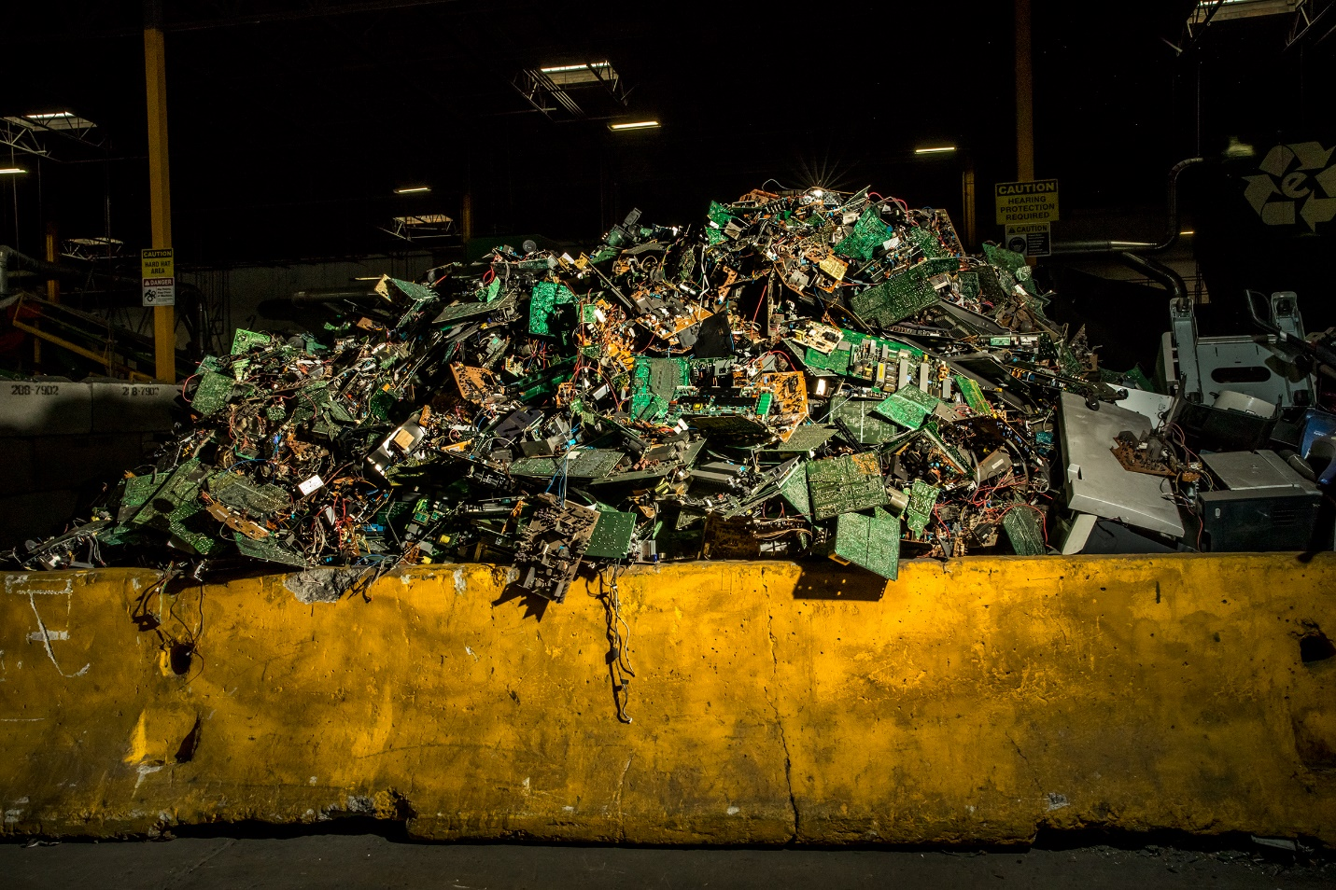

E-waste is on the rise, as more and more people discard more and more technology, there must be somewhere for it to go. E-waste is difficult to process and is full of toxic chemicals like lead and mercury. Often, e-waste is shipped away to developing countries, so that we don’t have to deal with it. The problem is that once in these countries, the waste is burned to extract precious metals like gold and copper. This releases toxins directly into the atmosphere, where it poses a severe health hazard to people and the environment.

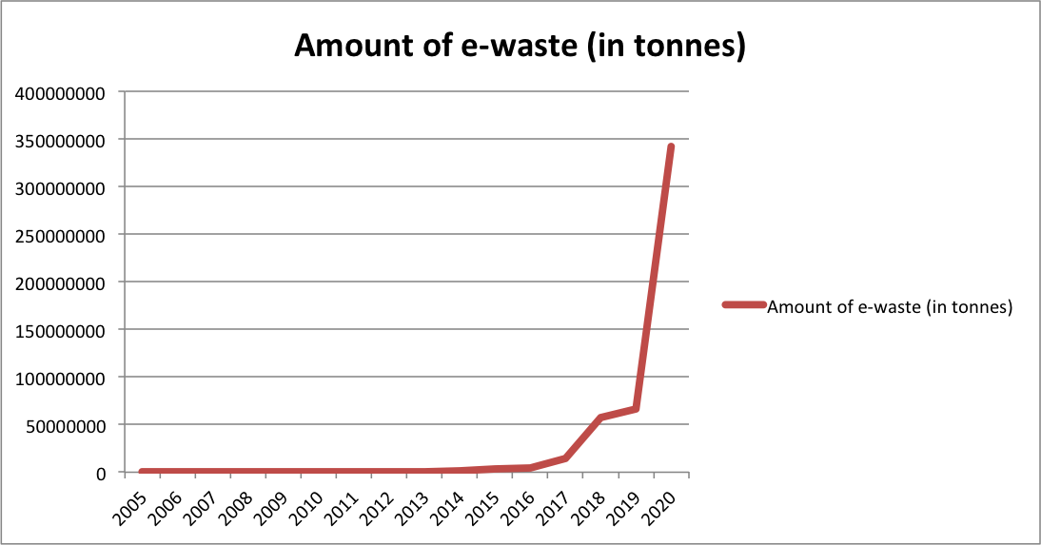

As you can see by the graph, e-waste has been growing exponentially throughout the 2000s. If we don’t do something about this problem, e-waste will just keep on increasing more and more. As companies are limiting repairability in favor of profit and our lives are becoming increasingly digital, we end up throwing out more and more electronics, contributing to the growing problem of e-waste.

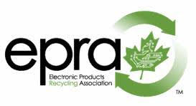

The Electronics Products Recycling Association is a non-profit industry led organization that is dedicated to properly dealing with e-waste in Canada. They ensure that e-waste isn’t put in the landfill or illegally exported overseas to a developing country. The EPRA works with audited recyclers to recover the precious metals within discarded electronics, allowing the preservation of our natural resources. The EPRA gains its funding through the Electronics Handling Fee, a fee on every electronic device purchased, that covers the cost of the entire recycling process.

Starting January 1st, 2021, after the retirement of the Ontario Electronic Stewardship program, Ontario moved to a producer responsibility model for recycling. This means that the producers that make the products are responsible for the full life cycle of said product. The EPRA offers to help producers with the recycling stage of their product’s life cycle.

The Environmental Handling fee is a fee that business can offer to their customers to recover the costs of recycling. The fee will often be found on hazardous materials including e-waste, and the amount is at the businesses’ discretion.

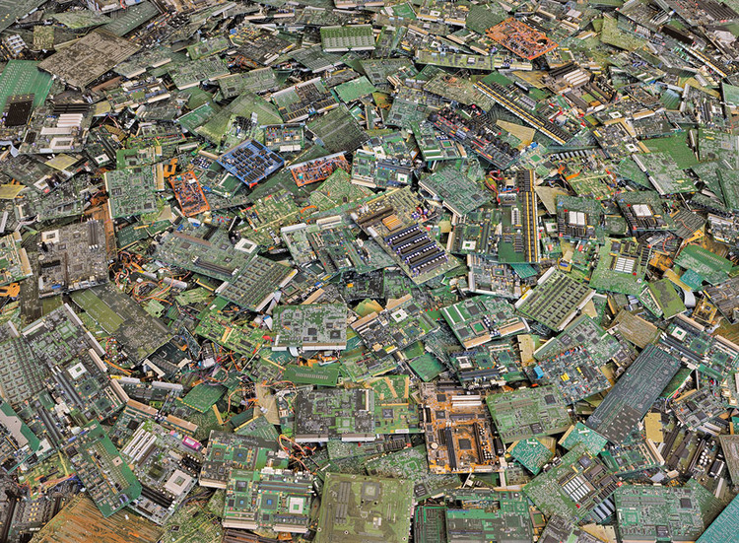

As a student, it is essential that you properly recycle e-waste. As cell phones and smart watches are becoming increasingly more prevalent, it is important that you don’t just throw your digital devices into the landfill. You must do your part to protect the environment, and the lives of the people that are affected by improper e-waste treatment.

For residents living in Goderich ON, the closest e-waste drops off point is the Blue Water Recycling Association near Centralia. If any Goderich residents found themselves heading towards Stratford, they could also drop off their e-waste there.

Once again, it is essential that every person does their part to help save our environment and ourselves from the growing problem of e-waste.